Press Release
Glashütte, February 2018

Moritz Grossmann receives patent for the BENU Tourbillon minute display

Launched in 2013, the BENU Tourbillon with the flying three-minute tourbillon incorporates several developments conceived by Grossmann’s watchmakers for which utility model or patent applications were filed: the V-shaped design of the balance bridge (utility model registered), the stop seconds mechanism with a hair brush (patent pending) and the double minute display (patent pending).

In January 2018, the double minute display was the first of the new developments to receive a European patent (No. 2874021). To accommodate a particularly large tourbillon and an appropriately large tourbillon aperture in the dial of the BENU, the centre minute display relies on two scales. The outer scale is interrupted by the tourbillon aperture in the range from 25 to 35 minutes; the missing segment is replaced by the inner scale. When the minute hand transits the tourbillon aperture, its extension sweeps the inner scale, allowing precise readings during that ten-minute interval. The attractive and unusual solution lives up to the ambition of delivering uncompromising precision.

Moritz Grossmann Uhren:
Moritz Grossmann, born in Dresden in 1826, was deemed a visionary among Germany's great horologists. In 1854, his friend Ferdinand Adolph Lange persuaded the young, highly talented watchmaker to establish his own mechanical workshop in Glashütte. Apart from building a respected watchmaking business, Grossmann was committed to political and social causes. He established the German School of Watchmaking in 1878. Moritz Grossmann passed away unexpectedly in 1885, after which his manufacture was liquidated.
The spirit of Moritz Grossmann's horological traditions sprang back to life in 2008 when trained watchmaker Christine Hutter discovered the venerable Glashütte brand and had it re-registered. She developed concepts and was inspired by the vision of reviving Grossmann's legacy more than 120 years later with a particularly exquisite wristwatch. And she convinced private watch enthusiasts to support her in making this dream come true. On 11 November 2008, she incorporated Grossmann Uhren GmbH in Glashütte.
At Grossmann, gifted watchmakers are preserving traditions without copying historic timepieces. With innovation, superb craftsmanship, a combination of traditional and contemporary manufacturing methods as well as precious materials, they are celebrateing "Pure watchmaking artistry since 1854" in their watches.

www.grossmann-uhren.com

For further information and high-resolution images, please contact:

GROSSMANN UHREN GmbH
Rainer Kern – Director of Communication
Uferstr. 1
01768 Glashütte
Tel: 0049-35053-320020
Fax: 0049-35053-320099
rainer.kern@grossmann-uhren.com

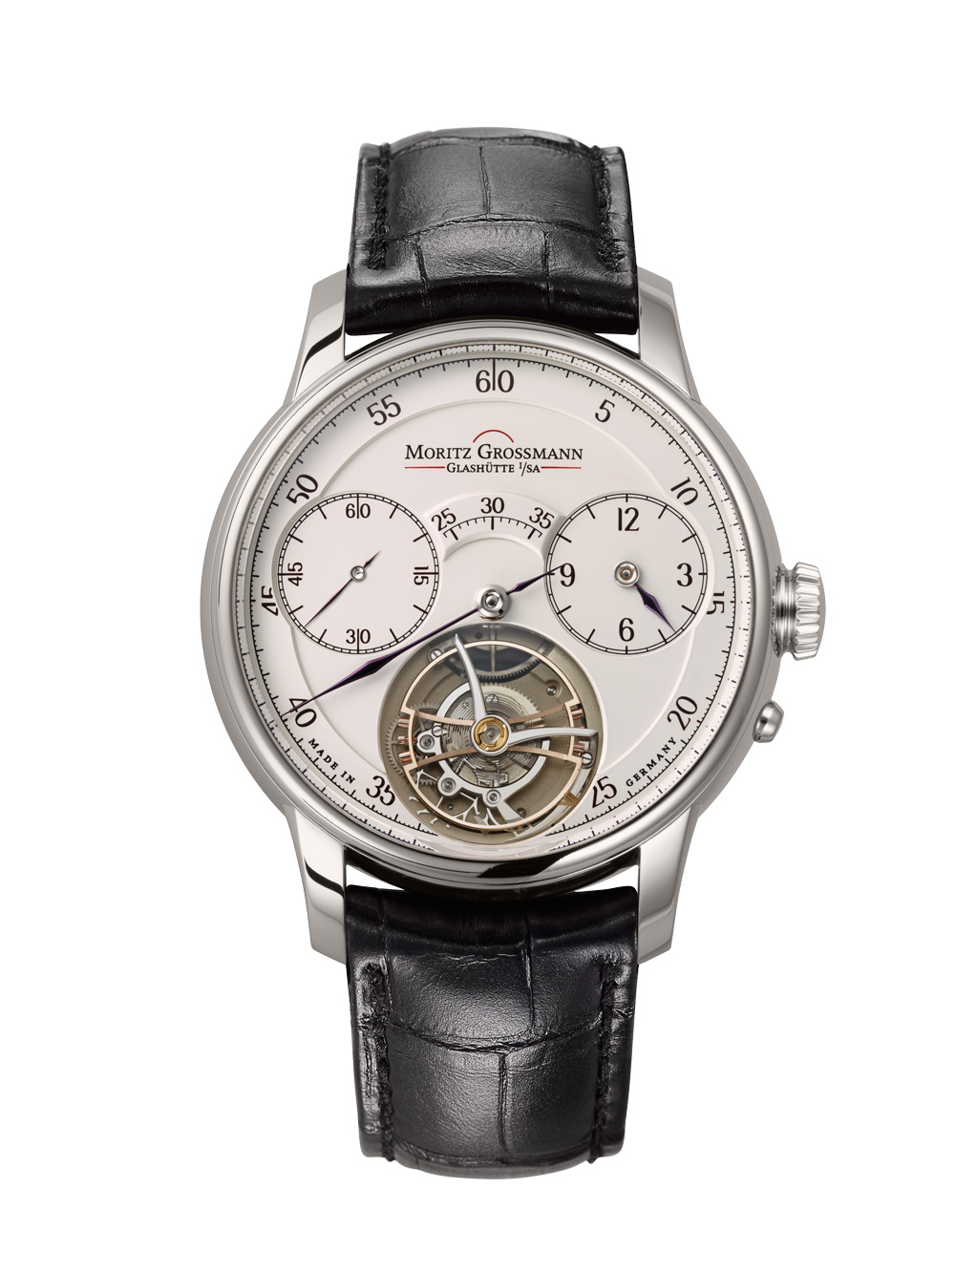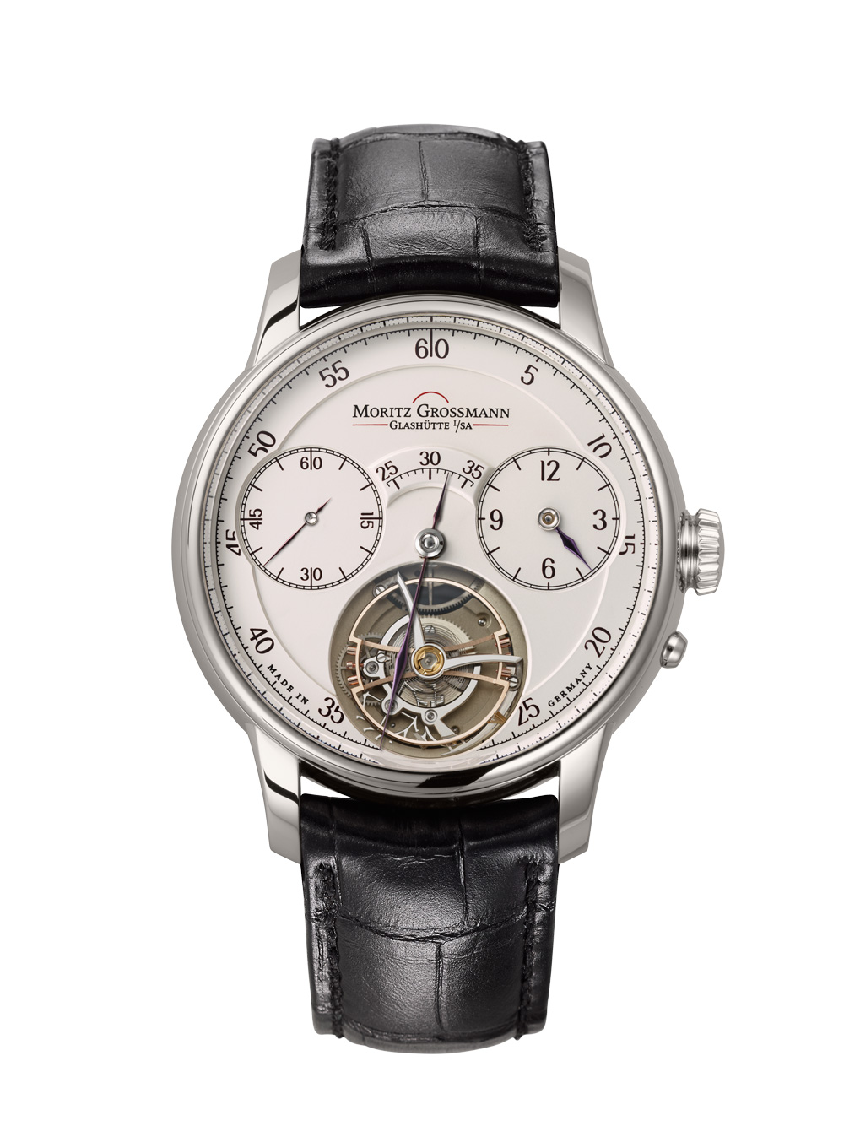
BENU Tourbillon BENU Tourbillon
showing the extension of the minute hand showing the extension of the minute hand
outside the second scale inside the second scale

