Press release
Glashütte, January 2017

Moritz Grossmann Uhren presents the ATUM Pure High Art with High-Artistic-Finish
The Moritz Grossmann Glashütte i/sa introduces a new limited edition: the ATUM Pure High Art

Grossmann is introducing a special version of the ATUM Pure in a stainless steel case with the calibre 100.1 movement featuring the precious High-Artistic Finish – the ATUM Pure High Art. From the outside, the ATUM Pure High Art is nearly unchanged. The steel case underscores the technical nature of the model family. Its dial is endowed with a fine brushed texture and is lacquered in white, grey, or blue. Burnished chamfers on the seconds dial and along the applied markers amplify the sporty nature of the watch. With their straight edges and broad chamfers, the lancet-shaped hands match the marker style. They are hand sculpted from stainless steel, a modern material that retains its toughness after tempering. After their openings are filled with white "Hy-Ceram", the hands are meticulously polished to attain their final look.

Pure Watchmaking Artistry

The calibre 100.1 can be admired through the ample, non-reflective sapphire-crystal display back. Subtly proportioned components in untreated German silver with different types of finissage constitute the individual levels of the pillar movement. The signature is hand-engraved into the characteristic 2/3 plate decorated with wide horizontal ribbing. The circular cutout of the plate reveals the Grossmann balance. It is carried by the cantilevered, hand- engraved balance cock with the typical micrometer screw. The Grossmann winder with pusher features a refined handsetting mechanism that eliminates two possible error sources: the ingress of particles into the case while the hands are being set and the unintentional alteration of the hand positions while the crown is being pushed home again. The ATUM Pure High Art also embodies all the hallmarks and underlying values of a classically crafted timepiece signed MORITZ GROSSMANN GLASHÜTTE I/SA.

Versions

The special edition of the ATUM Pure High Art comes with white, grey, and blue dials. All three versions of this edition are limited 15-watch editions within the 150 watch limitation per dial version of the ATUM Pure.

Technical data

Movement Manufacture calibre 100.1, manually wound, adjusted in five position
No. of parts 198
No. of jewels 20 jewels, 3 of which in screwed gold chatons
Escapement Lever escapement
Oscillator Shock-absorbed Grossmann balance with 4 inertia and 2 poising screws, Nivarox 1 balance spring with No. 80 Breguet terminal curve, Gerstenberger geometry
Balance Diameter 14.2 mm, frequency 18,000 semi-oscillations per hour
Power reserve 42 hours when fully wound
Functions Hours and minutes, subsidiary seconds with stop seconds, Grossmann winder with pusher
Special features Grossmann balance; lateral pusher for disabling the handsetting mode and starting the movement; space saving and modified Glashütte stopwork with backlash; adjustment with Grossmann micrometer screw on a cantilevered balance cock; Pillar movement with 2/3 plate and frame pillars in untreated German silver; 2/3 plate, balance cock, and escape-wheel cock engraved by hand; broad horizontal Glashütte ribbing; 3-band snailing on the ratchet wheel; raised gold chatons with pan-head screws; separately removable clutch winder; stop seconds for handsetting
Operating elements Crown for winding the watch and setting the time, pusher to start movement
Case dimensions Diameter: 41.0 mm, height: 11.35 mm
Movement dimensions Diameter: 36.4 mm, height: 5.0 mm
Case Three-part, stainless steel
Dial hour markers stainless steel, rhodiumed
Hands Hand-crafted, hour and minute stainless steel, polished, with white HyCeram filling, subsidiary second stainless steel
Crystal and display back Sapphire crystal, antireflective coating on one side
Strap Hand-stitched alligator strap with prong buckle in stainless steel

Versions:

Reference MG02.B-04-A000822
Dial Blue
Limitation 15 watches

Reference MG02.B-04-A000825
Dial Grey
Limitation 15 watches

Reference MG02.I-04-A000819
Dial White
Limitation 15 watches

Moritz Grossmann Uhren:
Moritz Grossmann, born in Dresden in 1826, was deemed a visionary among Germany’s great horologists. In 1854, his friend Ferdinand Adolph Lange persuaded the young, highly talented watchmaker to establish his own mechanical workshop in Glashütte. Apart from building a respected watchmaking business, Grossmann was committed to political and social causes. He established the German School of Watchmaking in 1878. Moritz Grossmann passed away unexpectedly in 1885, after which his manufacture was liquidated.
The spirit of Moritz Grossmann’s horological traditions sprang back to life in 2008 when trained watchmaker Christine Hutter discovered the venerable Glashütte brand and had it re-registered. She developed concepts and was inspired by the vision of reviving Grossmann’s legacy more than 120 years later with a particularly exquisite wristwatch. And she convinced private watch enthusiasts to support her in making this dream come true. On 11 November 2008, she incorporated Grossmann Uhren GmbH in Glashütte.
At Grossmann, gifted watchmakers are preserving traditions without copying historic timepieces. With innovation, superb craftsmanship, a combination of traditional and contemporary manufacturing methods as well as precious materials, they have created an “Origin of a new time” with their watches.

www.grossmann-uhren.com

For further information and high-resolution images, please contact:
GROSSMANN UHREN GmbH
Rainer Kern – Director of Communication
Uferstr. 1
01768 Glashütte
Tel: 0049-35053-320020
Fax: 0049-35053-320099
rainer.kern@grossmann-uhren.com

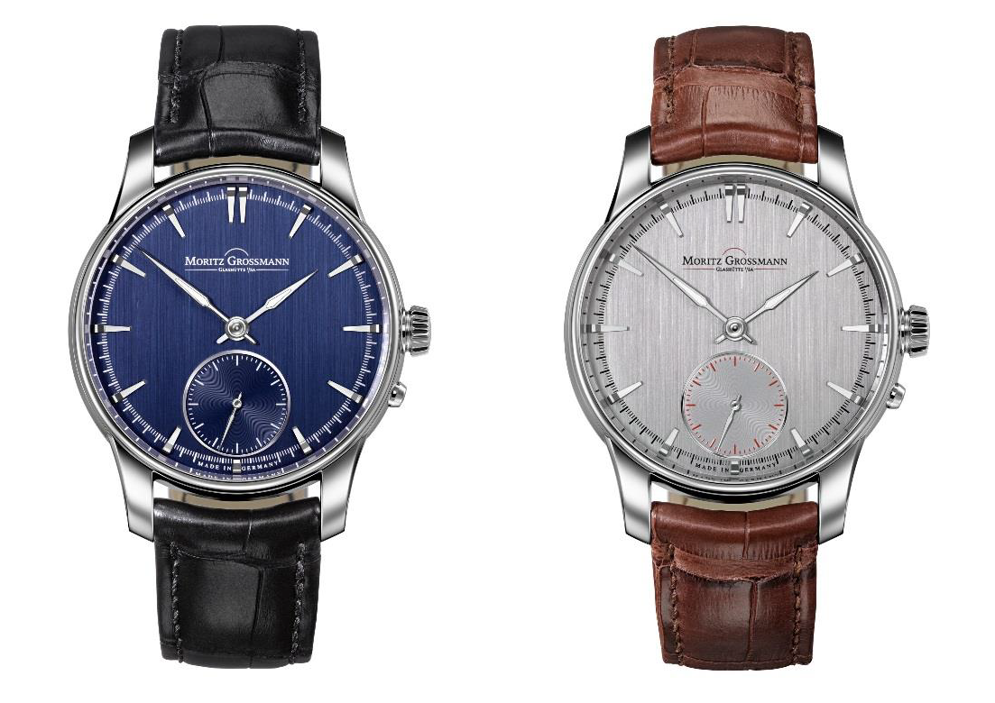

ATUM Pure High Art ATUM Pure High Art

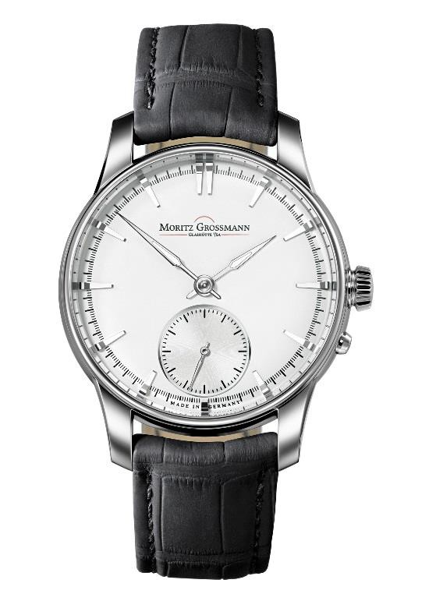
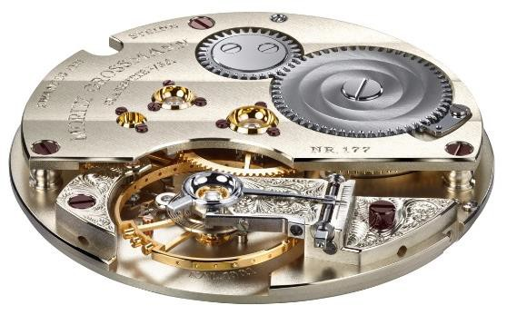
ATUM Pure High Art Kaliber 100.1

