Press Release
Glashütte, July 15th 2018

Moritz Grossmann congratulates France with a World Cup football watch

Vive les Bleus! Vive la France!

20 years later, France has again won the World Cup and Moritz Grossmann is celebrating Les Bleus with the special-edition ATUM Pure Weltmeisteredition 2018.

Moritz Grossmann is surprising watch enthusiasts and football fans with this World Cup watch based on the ATUM Pure X line. A sporty steel case paired with an individually designed World Cup dial. The Calibre 201.1 boasts an eye-catching football-shaped filigree dial insert. The final score „4:2“ with the year 2018 will be emblazoned on the watch face and the fingers and straps will be in France’s national colours.

We congratulate France’s World Cup team and the whole country on this great result. 4:2! The number of limited-edition ATUM Pure Weltmeisteredition 2018 watches released corresponds to the number of goals in the final and so just six are available, and the German RRP will be 16,000 EUR incl. VAT.
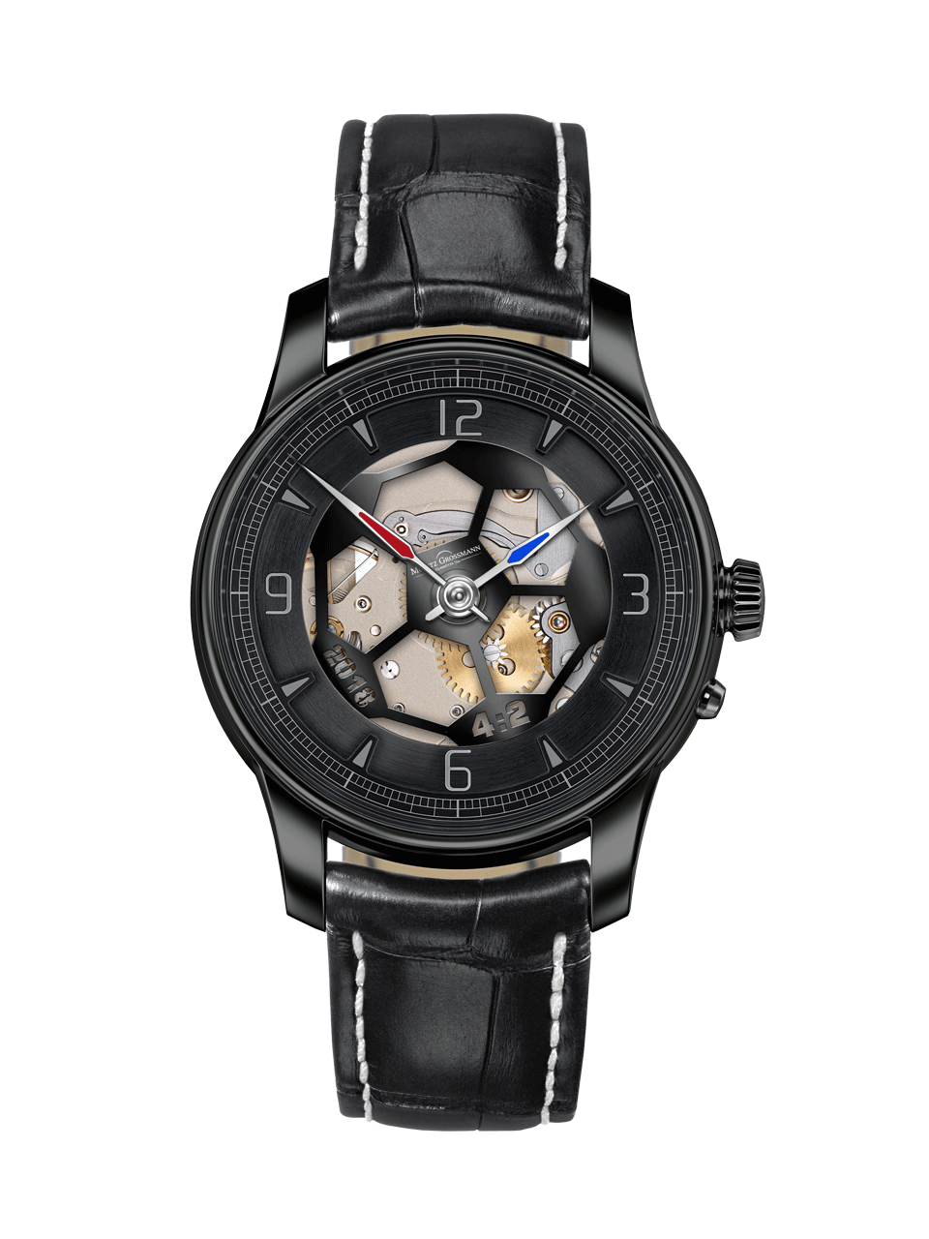
ATUM Pure Weltmeisteredition 2018
Moritz Grossmann Uhren:
Moritz Grossmann, born in Dresden in 1826, was deemed a visionary among Germany's great horologists. In 1854, his friend Ferdinand Adolph Lange persuaded the young, highly talented watchmaker to establish his own mechanical workshop in Glashütte. Apart from building a respected watchmaking business, Grossmann was committed to political and social causes. He established the German School of Watchmaking in 1878. Moritz Grossmann passed away unexpectedly in 1885, after which his manufacture was liquidated.
The spirit of Moritz Grossmann's horological traditions sprang back to life in 2008 when trained watchmaker Christine Hutter discovered the venerable Glashütte brand and had it re-registered. She developed concepts and was inspired by the vision of reviving Grossmann's legacy more than 120 years later with a particularly exquisite wristwatch. And she convinced private watch enthusiasts to support her in making this dream come true. On 11 November 2008, she incorporated Grossmann Uhren GmbH in Glashütte.
At Grossmann, gifted watchmakers are preserving traditions without copying historic timepieces. With innovation, superb craftsmanship, a combination of traditional and contemporary manufacturing methods as well as precious materials, they celebrate "Pure watchmaking artistry since 1854" with their watches.

Images for download:

https://my.hidrive.com/share/5v6vnfmn3x

Further information on Grossmann Uhren GmbH for download:

https://my.hidrive.com/share/a44bao2nf6

Grossmann Uhren GmbH:

www.grossmann-uhren.com

https://www.grossmann-uhren.com/news/?lang=de

For further information and high-resolution images, please contact:

PRESS CONTACT

GROSSMANN UHREN GmbH
Sandra Behrens – Communication Manager
Uferstr. 1
01768 Glashütte, Germany
Tel: 0049-35053-320020
Fax: 0049-35053-320099
E-mail: sandra.behrens@grossmann-uhren.com

