Press release
Glashütte, November 2016

BENU Tourbillon receives
"The Judges Choice Award 2016"

Grossmann honoured with Starhill Gallery top award
at "A Journey Through Time" 2016 in Kuala Lumpur.

The manufacture Moritz Grossmann looks back on its successful participation in the 10th edition of "A Journey Through Time" 2016 at the Starhill Gallery in Kuala Lumpur and the special rankings of two models. The multi-day event is one of Malaysia's most prestigious functions, attracting an exclusive roster of international watch and jewellery brands.

The event's top award is the special highlight for the manufacture Moritz Grossmann: The BENU Tourbillon in white gold with a black dial was honoured with THE JUDGES CHOICE AWARD 2016 "for the best unique and complicated timepieces of all nominations". Already last year, the BENU Tourbillon in white gold with a argenté dial was awarded with the STARHILL GALLERY WATCH WITH COMPLICATIONS IN MOVEMENT AWARD 2015.

In two further categories, Grossmann debuts were nominated to the five best of the entries:

- The TEFNUT 36 with a billant bezel finished among the five best in the
STARHILL GALLERY FAVOURITE LADIES' WATCH AWARD 2016

- The BENU Tourbillon in white with a black dial gold finished among the five best in the MINISTRY OF TOURISM & CULTURE MOST REVERED AWARD 2016

Technical Data BENU Tourbillon:

Movement Manufacture calibre 103.0, manually wound, adjusted in five positions
No. of parts: 245 (wheel train 186, cage 59)
No. of jewels 30, 4 of which in screwed gold chatons (wheel train 17, cage 13)
Escapement Lever escapement
Oscillator Grossmann three-minute tourbillon with stop seconds; shock-absorbed Grossmann balance with 4 inertia and 2 poising screws, suspended Nivarox 1 balance spring with No. 80 terminal curve, Gerstenberger geometry
Cage diameter 16.2 mm
Cage speed 1 revolution in three minutes, anti-clockwise when viewed from dial side
Balance diameter 14.2 mm, frequency 18,000 semi-oscillations per hour
Power reserve 72 hours when fully wound
Functions / features
­ Flying three-minute tourbillon with screw-secured driving wheel and V-shaped balance bridge (design patent pending)
­ Sweep minutes, off-centre hours and seconds with stop seconds, replacement of the missing minute scale segment from 25 to 35 minutes with a separate scale swept by the extension of the minute hand on the opposite side (patent pending)
­ Stop seconds at the balance wheel rim with a pivoting fine-hair brush (patent pending)
­ Asymmetric-arm lever escapement with counterweight and lever banking pin
­ Grossmann balance with suspended balance spring, adjustable with poising screws in the rim
­ Newly developed mainspring barrel jewel bearing
­ Brake ring on the fourth-wheel arbor made of very hard, oily guaiacum
­ ARCAP train wheels
­ Grossmann winder with pusher to deactivate the handsetting mode and start the movement
­ Modified Glashütte stopwork with backlash
­ Pillar movement with 2/3 plate and frame pillars in untreated German silver
­ Hand-engraved 2/3 plate and tourbillon cock
­ Broad horizontal Glashütte ribbing
­ 3-band snailing on the ratchet wheel
­ Raised gold chatons with pan-head screws
­ White sapphire bearing jewels
­ Separately removable clutch winder
Operating elements Crown in 750/000 white gold to wind the watch and set the time, pusher in 750/000 white gold to start the movement
Case dimensions Diameter: 44.5 mm, height: 13.8 mm
Movement dimensions Diameter: 38.4 mm, height: 7.1 mm
Case Three-part, in 750/000 white gold
Dial: Solid silver, three-part, with Arabic numerals
Hands Hand-crafted, steel, annealed to a brown-violet hue or stainless steel
Crystal/display back Sapphire crystal, antireflective coating on one side
Strap Hand-stitched alligator strap with butterfly clasp in 750/000 white gold

Versions:

Reference MG01.G-02-A000004
Dial argenté
Limitation 50 watches

Reference MG01.G-02-A000779
Dial black
Limitation 10 watches

Moritz Grossmann Uhren:
Moritz Grossmann, born in Dresden in 1826, was deemed a visionary among Germany’s great horologists. In 1854, his friend Ferdinand Adolph Lange persuaded the young, highly talented watchmaker to establish his own mechanical workshop in Glashütte. Apart from building a respected watchmaking business, Grossmann was committed to political and social causes. He established the German School of Watchmaking in 1878. Moritz Grossmann passed away unexpectedly in 1885, after which his manufacture was liquidated.
The spirit of Moritz Grossmann’s horological traditions sprang back to life in 2008 when trained watchmaker Christine Hutter discovered the venerable Glashütte brand and had it re-registered. She developed concepts and was inspired by the vision of reviving Grossmann’s legacy more than 120 years later with a particularly exquisite wristwatch. And she convinced private watch enthusiasts to support her in making this dream come true. On 11 November 2008, she incorporated Grossmann Uhren GmbH in Glashütte.
At Grossmann, gifted watchmakers are preserving traditions without copying historic timepieces. With innovation, superb craftsmanship, a combination of traditional and contemporary manufacturing methods as well as precious materials, they have created an “Origin of a new time” with their watches.

www.grossmann-uhren.com

For further information and high-resolution images, please follow the link or contact:

MORITZ GROSSMANN CONTACT:

GROSSMANN UHREN GmbH
Rainer Kern – Director of Communication
Uferstr. 1
01768 Glashütte
Tel: 0049-35053-320020
Fax: 0049-35053-320099
rainer.kern@grossmann-uhren.com

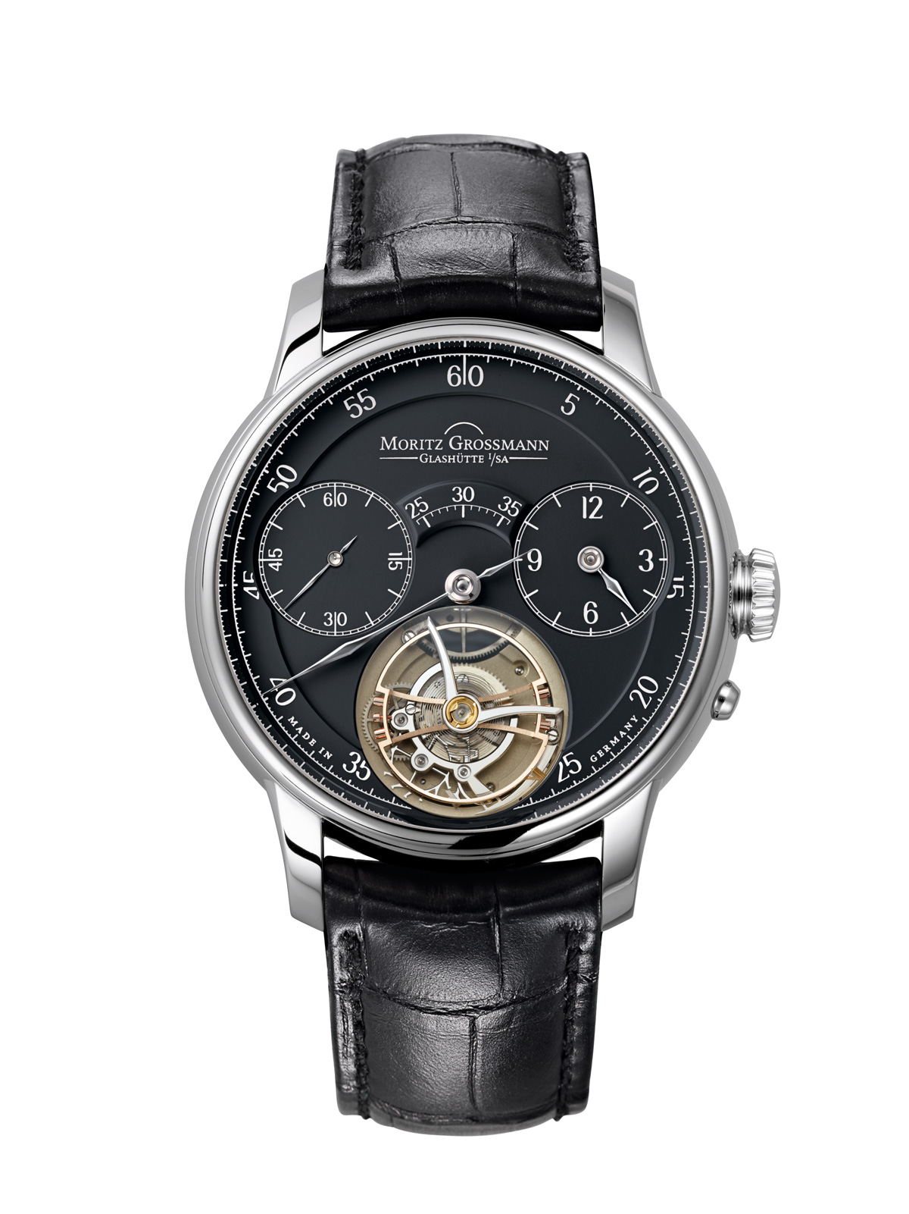

BENU Tourbillon
Ref. MG01.G-02-A000779
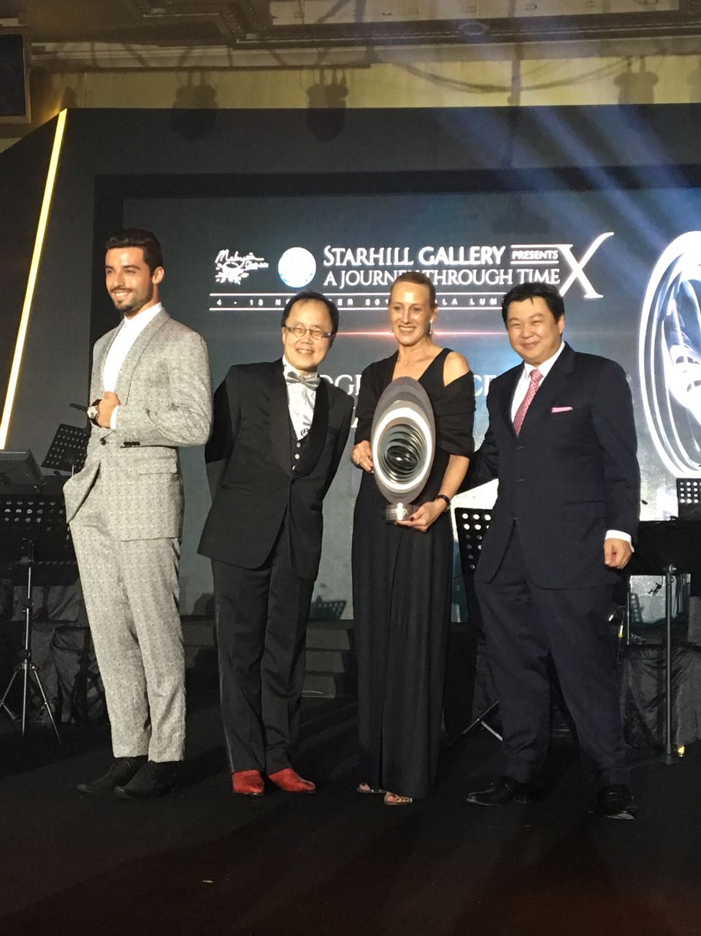

Dr. Bernard Cheong, Doctor, Horologist and Watch Collector
Christine Hutter, Founder and CEO Moritz Grossmann
Joseph Yeoh, Vice President YTL Land & Development and YTL Hotels and Properties

